**E-PROJECT**

**LABAUTOMATION**

**WEBSITE**

**USER GUIDE**

**PROJECT GROUP MEMBERS**

|  |  |
| --- | --- |
| **STUDENT ID** | **STUDENT NAME** |
| Student:1294952 | AASIA |
| Student:1316986 | SAMRA JAVAID KHAN |
| Student: 1276643 | MUHAMMAD HAMZA |
| Student:1305911 | RAZI SIDDIQUE |

**CURRICULUM:**

**OV-ACCP Prime-6740-ACE**

**BATCH:**

**2104B1**

**FACULTY:**

**Miss Muniba Javaid**

**CO-ORDINATOR:**

**Miss Areeba**

**INSTITUTE:**

**Aptech North Nazimabad**

**User-guide:**

A user guide, also commonly known as a user manual, is **intended to assist users in using a particular product, service, or application**. It's usually written by a technician, product developer, or a company's customer service staff.

**User-guide Includes:**

1. Plain Languages
2. Simplicity
3. Visuals­­­­­­
4. A focus on the problem
5. Logical hierarchy and flow
6. A table of content
7. Good design

**SNAPSHOTS**

**HOME PAGE**

When user open our website, they will see this user-

home page.

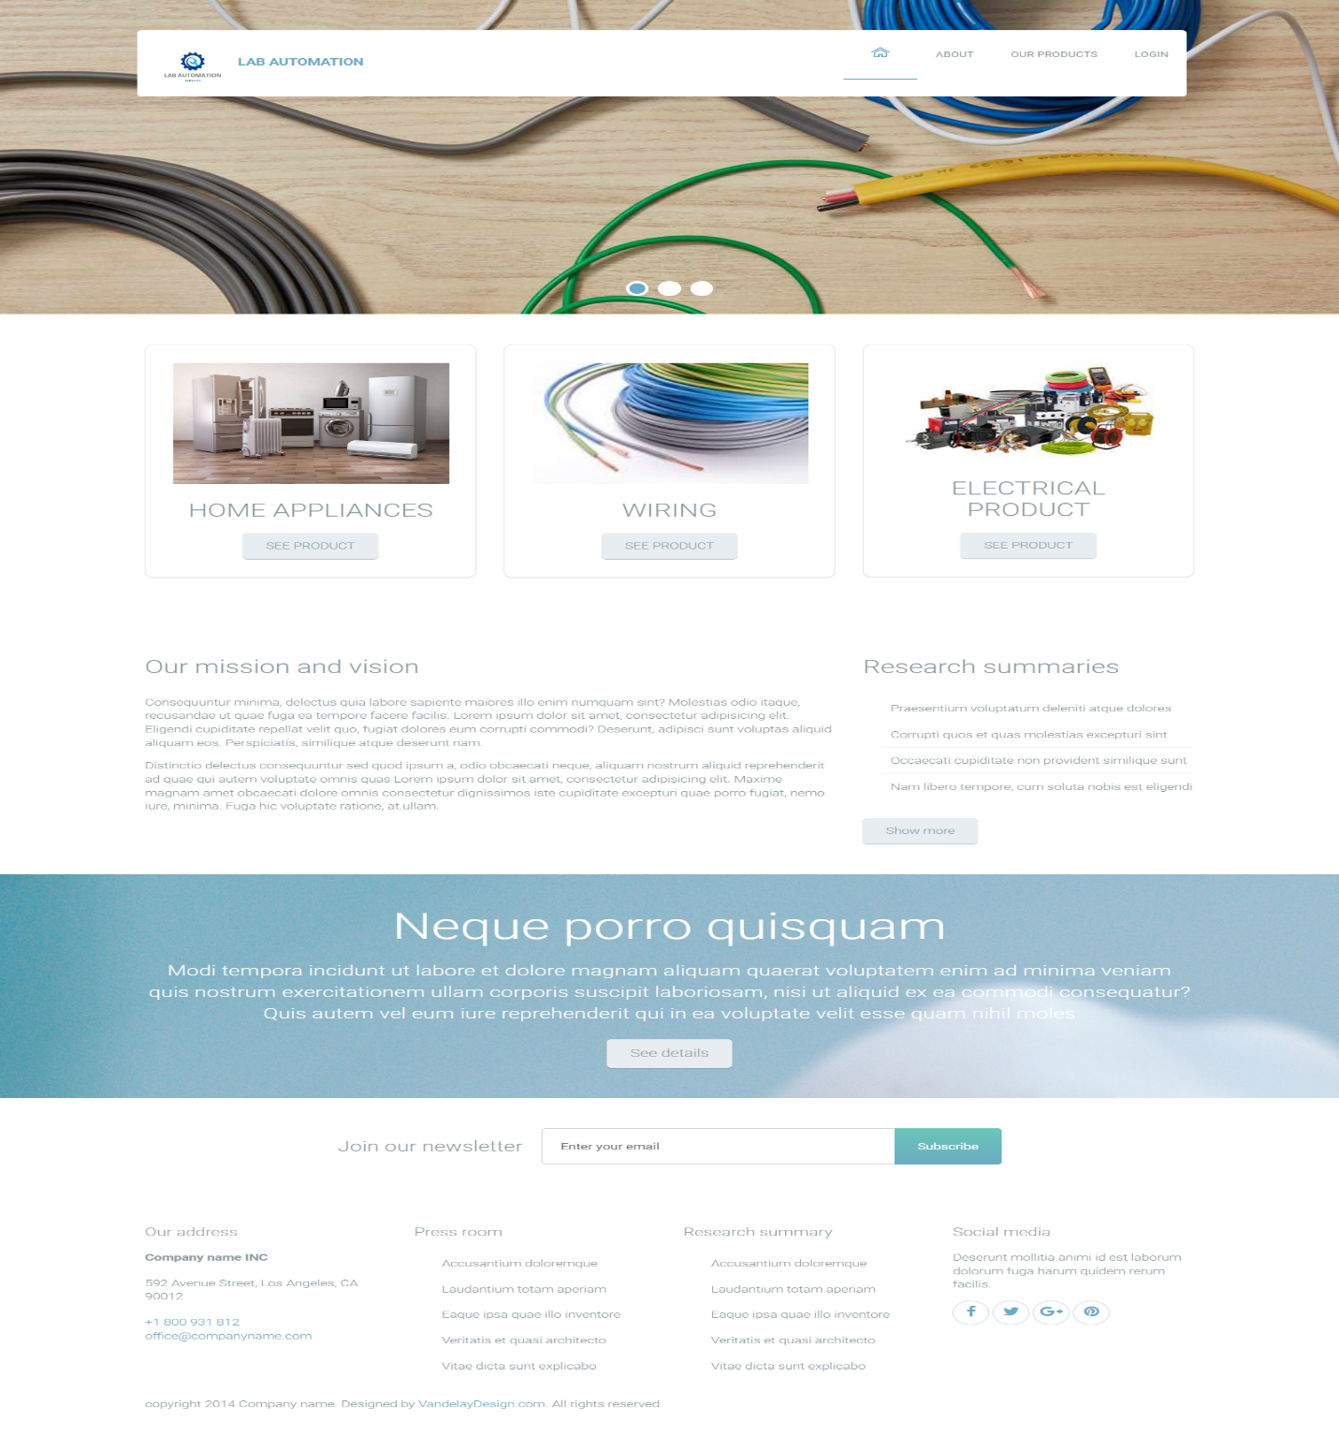

**ABOUT US**

At the same time user click on about us, they will see some 3 disparate section like details, about lab automation and testimonials.

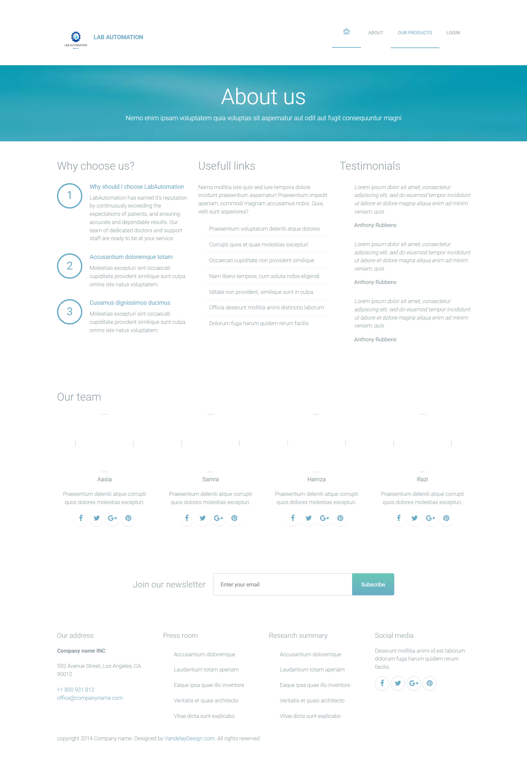

**PRODUCTS**

At the same time user click on product page anyone can access and see our products with their details

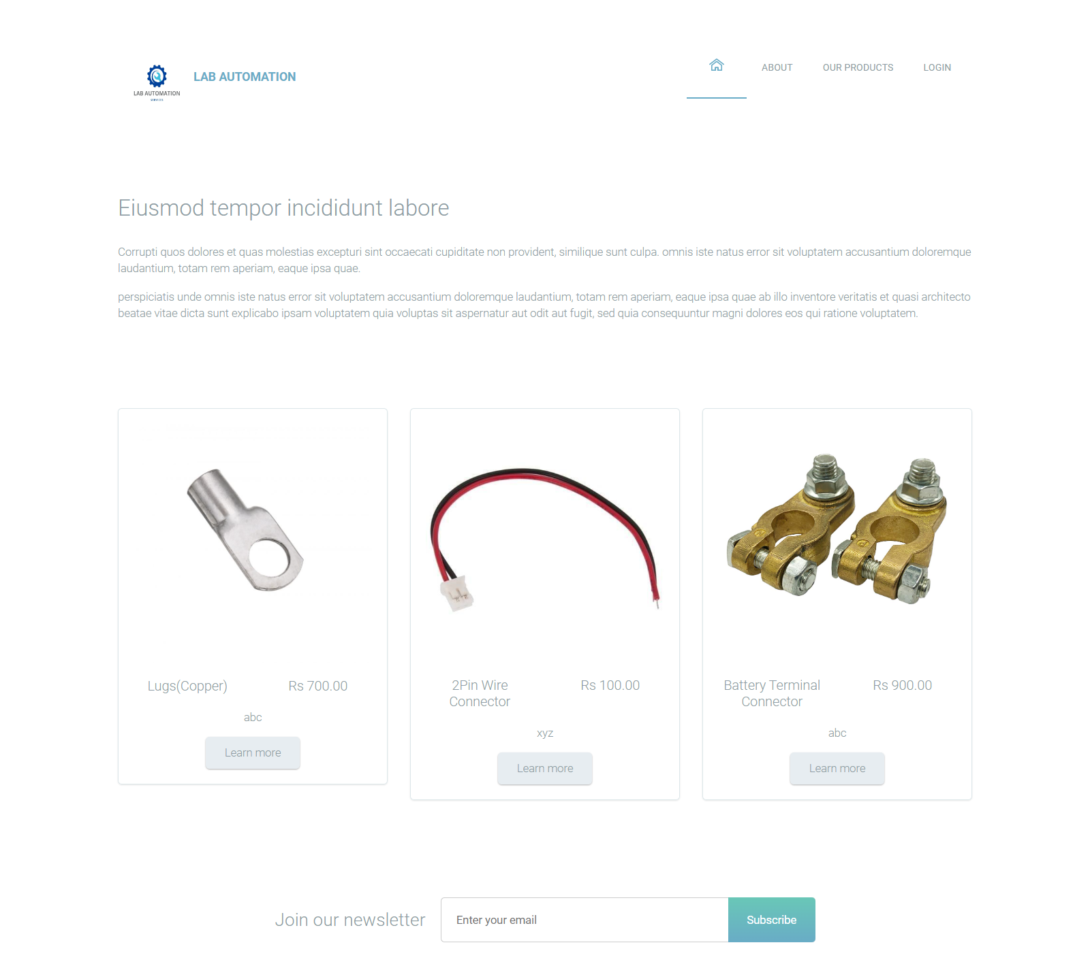

**LOGIN FORM**

In this curriculum we have three users firstly admin user secondly company user last but not the least laboratory user.



**ADMIN SITE**

**ADMIN LAYOUT**

When we login admin our website, they will see this admin

home page.

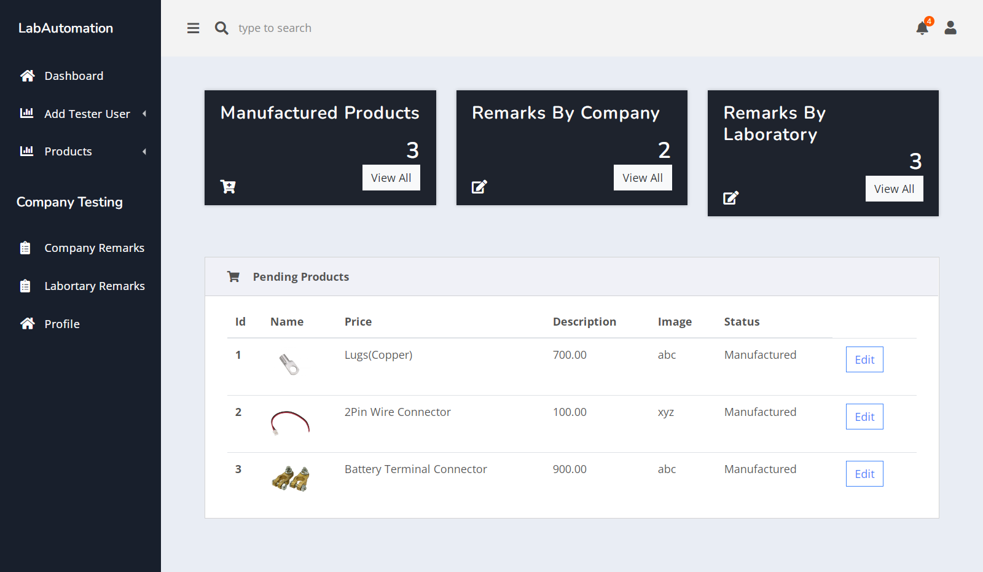

Add Tester:

In this page, how to add a user with the help of user tester add form.

* Fill-up a user add form
* All fields are mandatory
* Generate a password
* Form Submit

Now a user is successfully register in website.

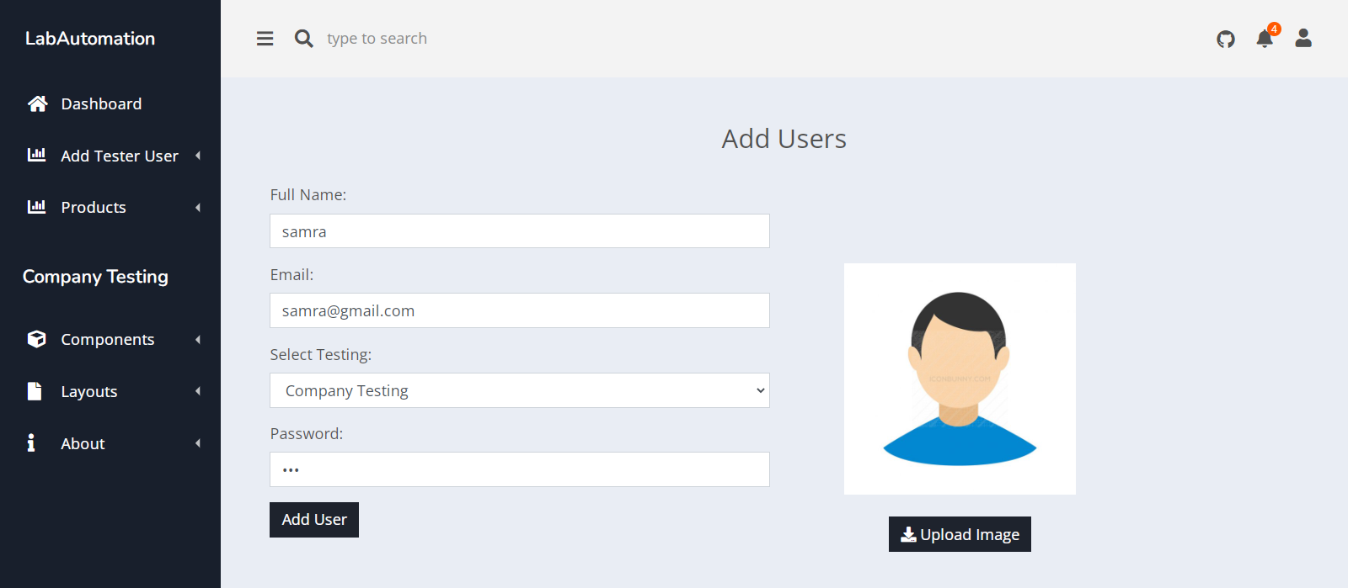

View-TESTER

In this page, we have shown an item what we are added tester users in view data tester users.

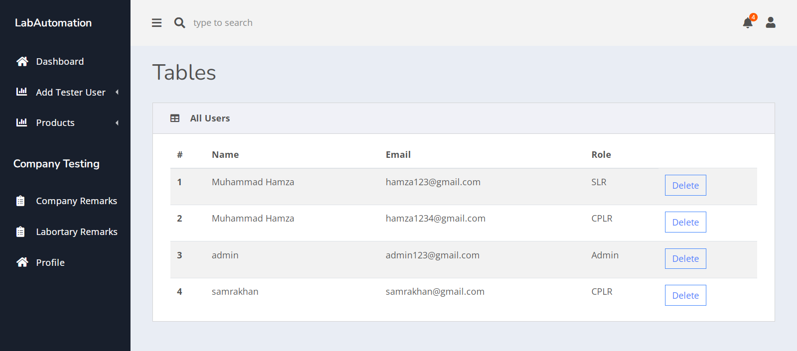

PRODUCTS

ADD PRODUCTS:

A user can add a product with the help of add product form.

User must fill-up all the requirements

* Product name
* Status
* Description
* Image
* Click on submit button

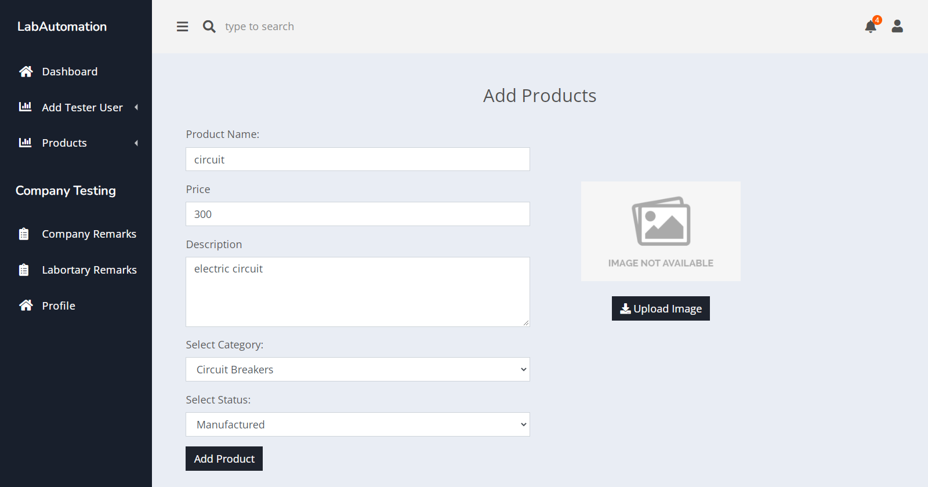

* Product is successfully added



COMPANY REMARKS:

Admin will see company remarks that the remarks will give the company.

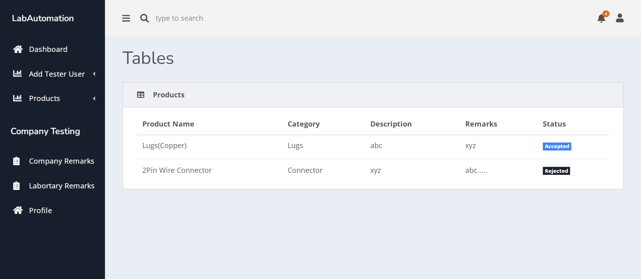

LABORATORY REMARKS:

Admin will see laboratory remarks that the remarks will give the laboratory.

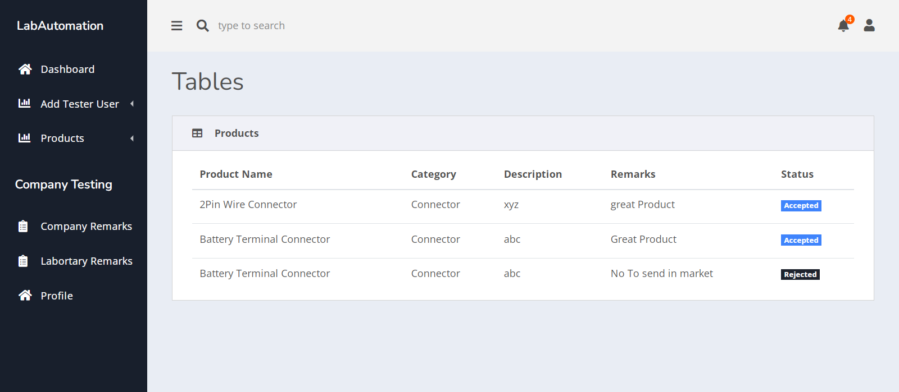

COMPANY SITE

PRODUCTS

TESTING-PRODUCTS

In this page we must focus on how company test the product. We have to show some of our products

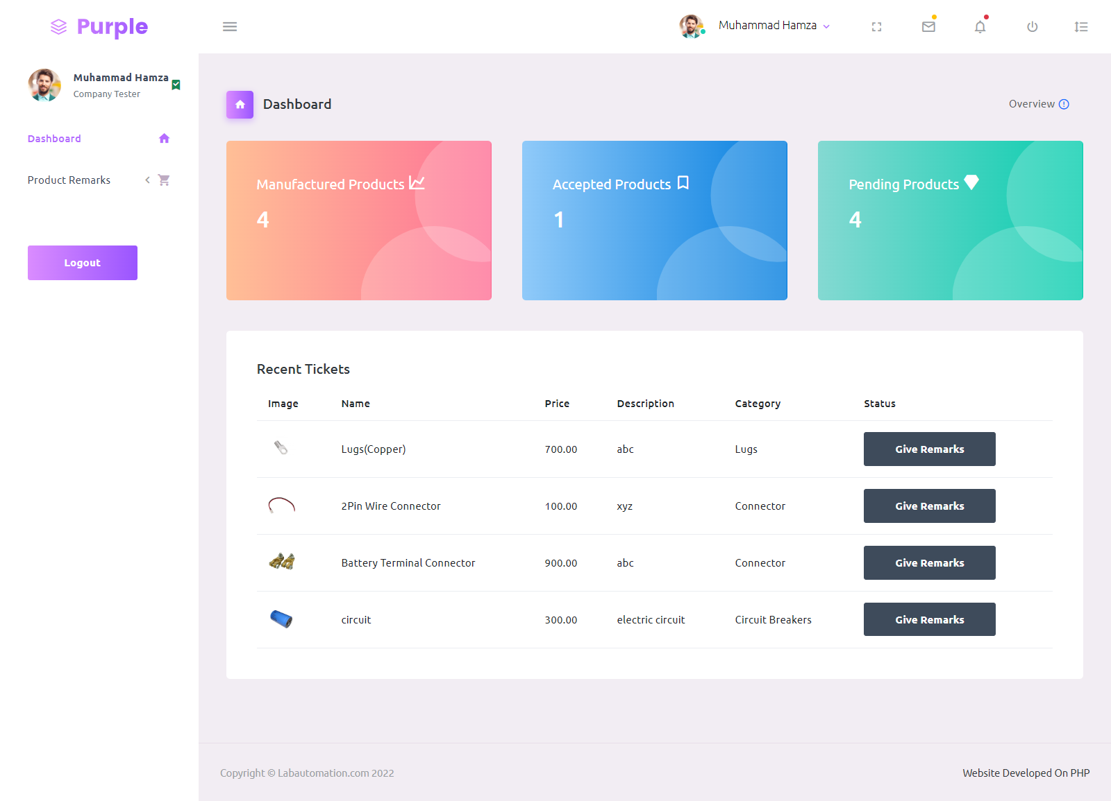

* If a company user clicks on give remarks, we have move to company tester form.
* Now fill-up the form.
* Submitted

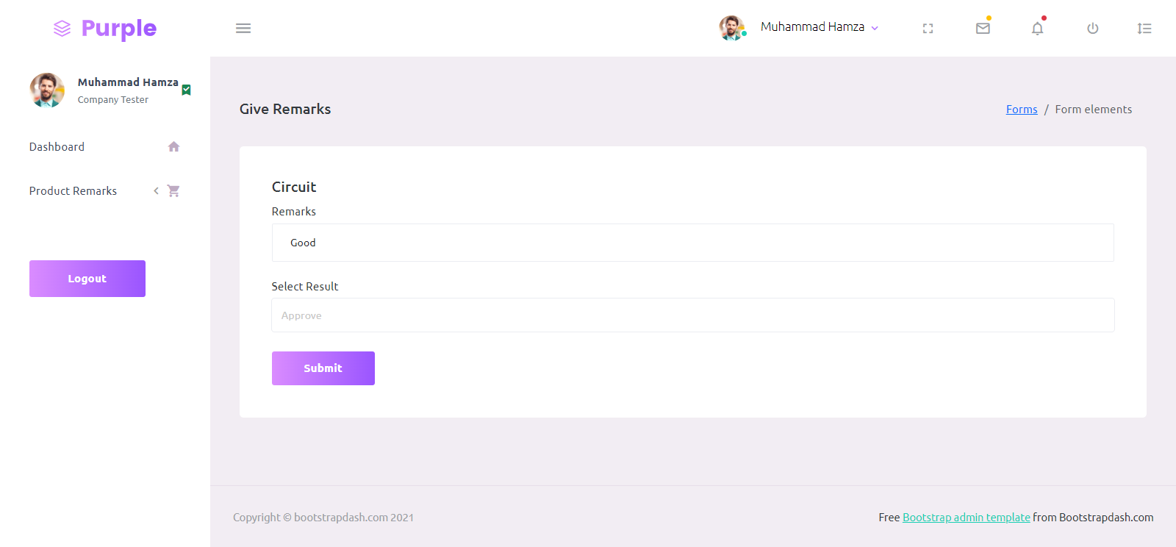

* If company tester approve the product the will show approved products as accepted list separately and also status will show accepted.

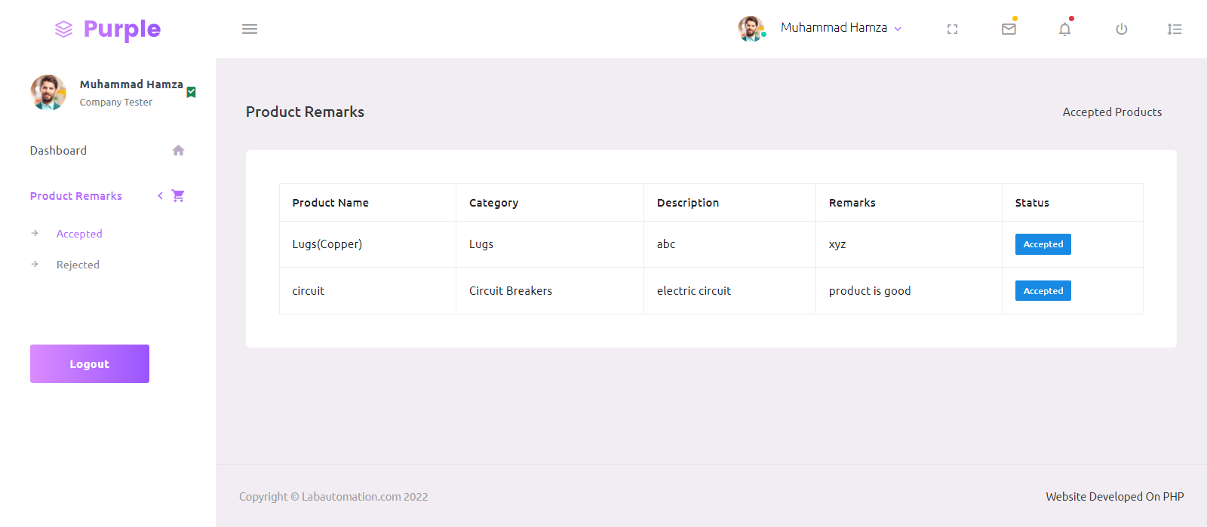

* If company tester reject the product the will show rejected products as rejected list separately and also status will show rejected.

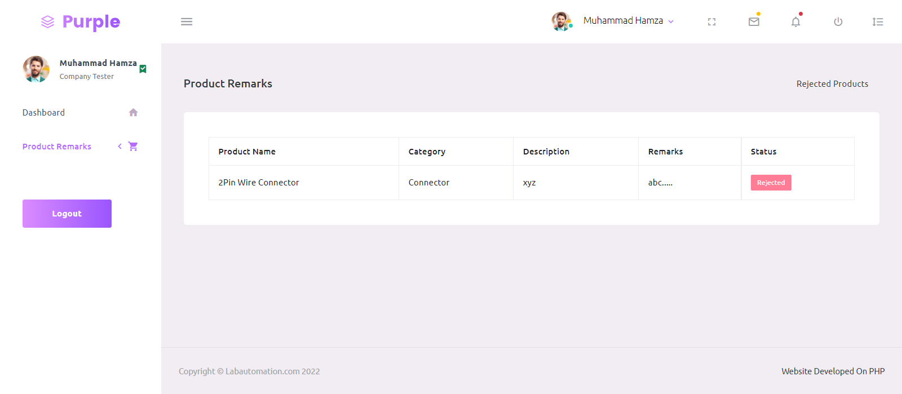

LABORATORY SITE

PRODUCTS

TESTING-PRODUCTS

In this page we must focus on how Laboratory test the product. We have to show some of our products

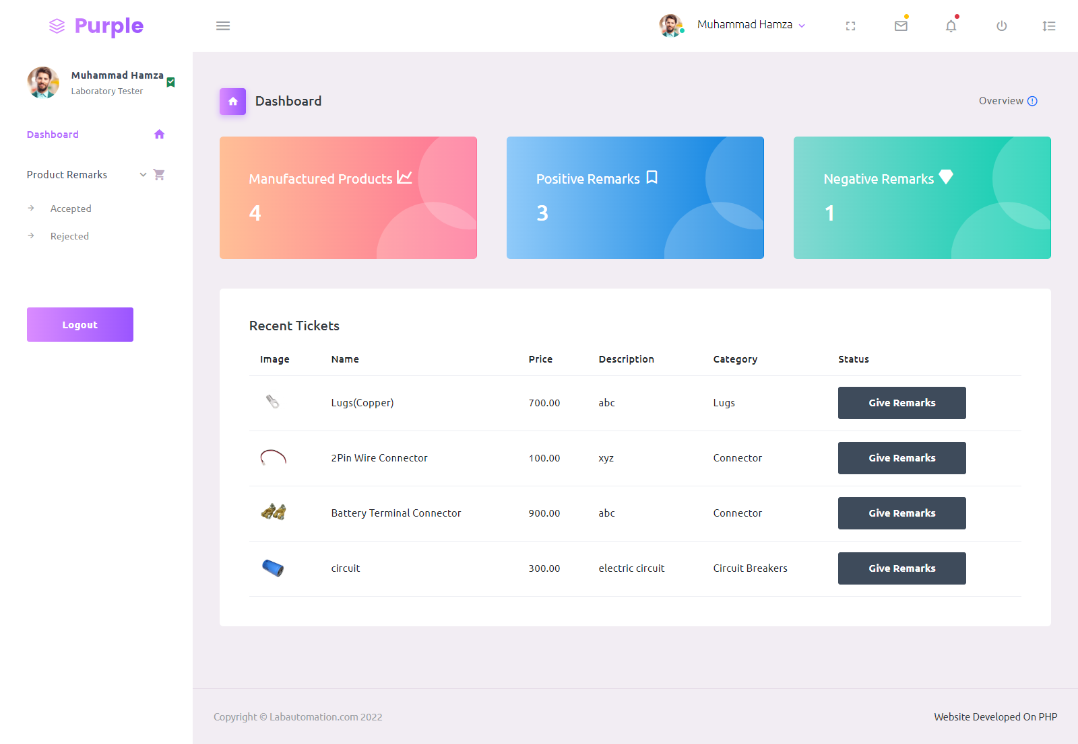

* If a company user clicks on give remarks, we have move to company tester form.
* Now fill-up the form.
* Submitted



* If laboratory tester approve the product the will show approved products as accepted list separately and also status will show accepted.



* If laboratory tester reject the product the will show rejected products as rejected list separately and also status will show rejected.



ERD DIAGRAM

